Service Description (SD) wm-data

**Abstract**

The wm-data provider gets sensor data from an active windmill and provides a wm-data service where it then stores the data in the DataManager’s historian service.

## Service Description Overview

The wm-data service provides one interface only. The interface provides sensor data from a windmill.

## Abstract Interfaces

## Wm-data

This interface provides the requested sensor data from the windmill.

## Function

When a request is received it takes the next value from the CSV file which contains the sensor data from the wind turbine.

The data is then parsed into a SenML message and is sent to the DataManager’s historian service for storing in the database. Then the data is sent to the consumer as a DTO.

## Sequence Diagrams

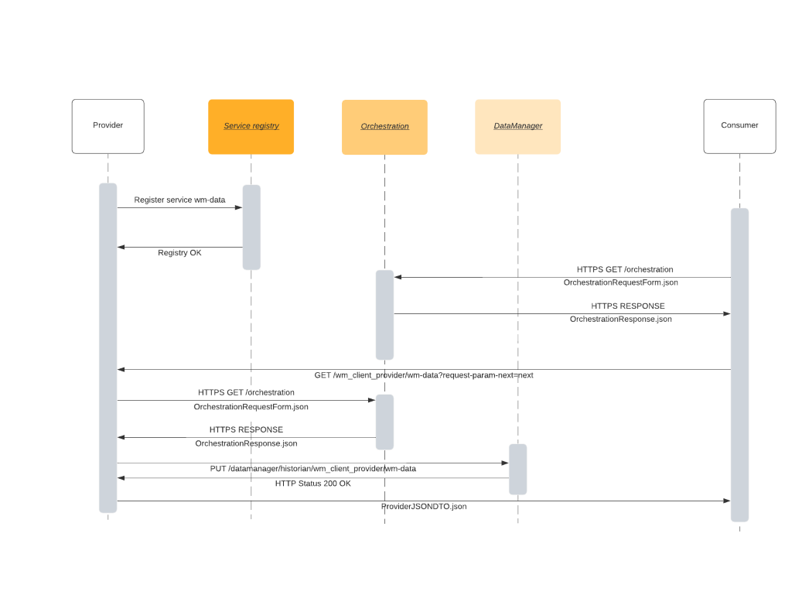

Figure 1: Sequence diagram requesting data from provider

The sequence diagram in Figure 1 shows the flow when a consumer is requesting data from the service wm-data. The provider is first registered automatically to the Service Registry. Then the consumer does an orchestration request to the Orchestration system. Upon receiving the orchestration response, a request for the next data point is sent to the provider. The provider is then reading the next data point. After data is read, the provider does an orchestration request for the Historian service and when the response is received the provider does a request to the Historian service. When the storage of data is done in the Historian, the provider sends its DTO with sensor data to the consumer.

## Abstract Information Model

* Timestamp
  + In years since measurement started
  + Type: Double
* Speed
  + Revolutions per minute of the main rotor axle
  + Type: Double
* Acceleration
  + Time series in Gs measured in the main rotor bearing
  + Type: Double
  + Will be a collection of 16384 measurements for the given data point

1. Non-functional Requirements

## References

## Revision history

## Amendments

|  |  |  |  |  |
| --- | --- | --- | --- | --- |
| No. | Date | Version | Subject of Amendments | Author |
| 1 | 2021-01-25 | 1.0 | First draft | Robin Jonsson |
| 2 | 2021-02-04 | 2.0 | Major updates to content | Robin Jonsson |
| 3 |  |  |  |  |
| 4 |  |  |  |  |

## Quality Assurance

|  |  |  |  |
| --- | --- | --- | --- |
| No. | Date | Version | Approved by |
| 1 |  |  |  |
| 2 |  |  |  |